Play Sport – Feel Good
Infopack
Youth exchange 23rd June- 1st July 2017

Welcome into our project “Play Sport- Feel Good”!

About the project…
The project was born when we realized the need to act regarding the Sport Education in the various European communities.
We realized many youngsters are less involved in sport activities because also of teaching methodology.
The causes can be many: the lack of free time, the increasing addiction to the technology and the presence of conflict and high competition inside of the sport enviroments. The participants will define more precisely the issues concerning this topic.
We will work on developing non formal methodology in order to turn sport education more inclusive, fair and equal for everyone. The Non Formal Education find space in many contexts, including the sport education.
The participants will work in group in finding new methodologies for teaching sports and they will implement them locally.

The venue

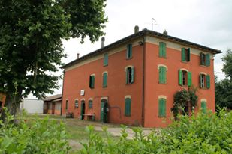
The YE will be host in "Casa Largaiolli", a building property of the Municipality of Sala Bolognese, really close to Bologna.
The venue is a rural building in a quite area with the perfect atmosphere to work fruitfully.
The partners should prepare the participants that the project takes place in the countryside and except one day visit to Bologna.
The building has been adapted for purpose of hosting groups and the setting is simple, completely surrounded by nature.
The toilets and the showers are outside the building (portable toilets).
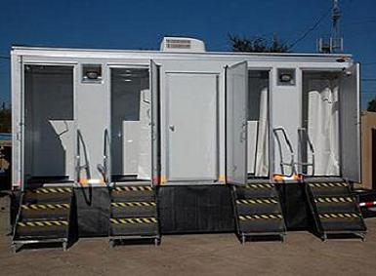
The wi-fi connection will be available only during the activities and the intercultural nights, to promote personal relations between the participants.
For this reason, we ask for your understanding with regard to the conditions of your stay.
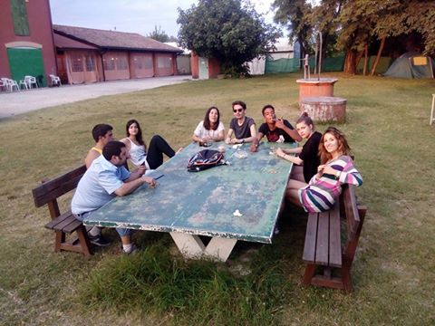

The bedrooms are dormitories with at least 4 beds

We suggest to bring with you staff and appropriate clothing in case of rain and cold.

At least one meal per day will be cooked by the participants, using the common cooking. We will try to have a balanced diet with a low consumption of meat.

THE PARTICIPANTS WILL BE RESPONSIBLE FOR THE CLEANING AND FOR TIDYING THE BUILDING.
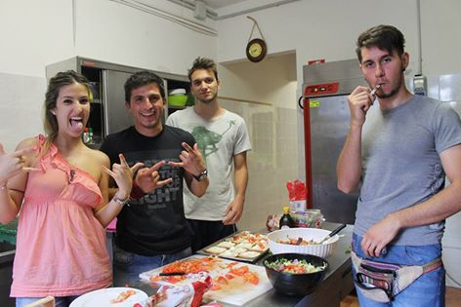

Participant’s profile

Number of participants from each country: 5 (4 + 1 group leader)

Participant’s characteristics:
- Minimum age: 18 – Maximum age: 25
- Experience in sport
- Motivation to use the acquired methods in their work
- Good level of English language
- Preferable participants: young people active within their organizations and with experience in the topic of the youth exchange, young people with experiences in the field of Erasmus+ project.
Please check that your health insurance card is still valid before the departure

Please fill in the participant’s form in English and send it to:
europe.belquel@gmail.com
Until the APV ( 20/21 may)
We would like to have the chance to see the filled participant’s form of the candidates before the final selection of participants.

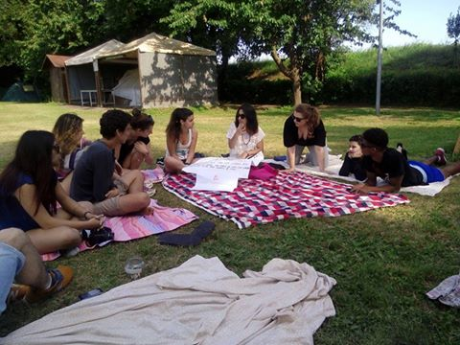

Costs
The YE won’t have a participation fee.
The hosting association will sustain accommodation and food. The travel will be reimbursed after attending the total duration of the project and AFTER THE PRESENTATION OF ALL THE TICKETS AND RECEIPS, so please keep all the documents with you. Without ticket and receipts, no reimbursements will be guarantee.
The travel costs will be reimbursed with this maximum:
Country | Max. Reimbursement
Estonia | 170€
Croazia | 170€
Cyprus | 270€
Spain | 170€

Participants MUST attend the whole duration of the youth exchange in order to receive the reimbursement

For more info:
Europe.belquel@gmail.com

